

Student Wellbeing Service Annual Report – 2023 -2024

Contents

Introduction 3
Wellbeing Initiatives 4
Policy Development 4
Training Initiatives during 2023-24 5
Additional Wellbeing Service training inputs offered over the 23-24 academic year: 6
Personnel changes within the Wellbeing Service 7
Counselling Services Section 8
Counselling Service Information 9
Wellbeing policies and strategies 10
Safeguarding Policies and provision 10
Suicide Response Strategy 11
Additional Wellbeing Activities 12
Counselling Service Data 13
Counselling Service Statistics 14
Total counselling sessions conducted in academic year 15
Analysis: 16
Counselling Registrations by Year of Study 17
Analysis of registrations by year of study: 17
Counselling Sessions by Ethnicity and Gender 19
Analysis of Gender and Race 19
Presenting issues 21
Analysis of Presenting Issues 22
Counselling Drop-in Sessions 23
Analysis of Drop-in Sessions 24
Total Counselling and Drop-in Sessions 25
Disabilities Reported by RADA Students Receiving Counselling 26
Analysis of Disabilities Reported in Counselling 26
SUMMARY 28
Statistics in Comparison to Past Two Previous Academic Years 28
Key Counselling Statistics and Presenting Issues 29
Conclusion and Recommendations 30
Disability Services Section 31
Summary of Disability Service Provision 32
Analysis of Disability Data 33
Disability Services Report Data 34

Introduction

The Student Wellbeing Service at RADA, encompassing both Counselling and Disability Services, provides confidential, free support to students. Over the past year, students and staff have used services, from talking therapies and disability registration assistance to support with Learning Agreements and providing workshops and trainings for staff and students, all aimed at ensuring a rewarding and meaningful experience for all students.
The RADA Counselling Service, part of the Student Wellbeing Service, offers up to six counselling sessions per academic year, including ongoing and brief sessions, and drop-in appointments for urgent needs. It provides confidential support for mild to moderate mental health issues through trained professionals.
Additionally, the service addresses practical needs and offers specialist support for a variety of concerns.
The Counselling Service has experienced a rise in clients this year and has increasingly collaborated with the Disability Service to manage and support students, carefully balancing their individual needs.
The Disability Service, now in its second year, also continues to grow. In April 2024, a third Disability Coordinator joined to deliver direct support to students and oversee six specialists aiding those with neurodiversity or mental health disabilities. The focus remains on informing and registering students for RADA's in-house Non-Medical Help (NMH) services available through Disabled Student Allowance.

Wellbeing Initiatives
Below are the key areas of activity of the Wellbeing Service over the past 2023-2024 academic year:

Policy Development

Safeguarding
In 2023, RADA established a dedicated Safeguarding Steering Group to ensure the safety and protection of the RADA community. The group has convened in December 2023, March 2024, and June 26. They have developed clear methods for monitoring students of concern and those identified as specific safeguarding risks.
Mental Health Strategy Development
A comprehensive Mental Health Strategy has been developed, incorporating the Qualtrics Questionnaire to gather feedback from staff and students. This initiative aims to better understand and address the mental health needs of the RADA community.
The document makes several recommendations to foster a mentally healthy environment for both staff and students. The questionnaire revealed similar responses from both groups regarding necessary workforce modifications to alleviate pressures.
Guidance on Suicide at RADA
As of June 2024, a draft guidance document on suicide prevention, intervention, and postvention is in circulation. This document aims to provide clear and accessible guidance on suicide to support the RADA community, offering crucial information and resources to prevent suicide and support those affected.

Training Initiatives during 2023-24

Training achievements during the 2023-2024 academic year include:

Mental Health Awareness for Staff and Students:
The Wellbeing Service has conducted training sessions for both staff and students, enhancing mental health awareness and fostering better understanding and support within the community.
Papyrus Suicide Awareness for Staff and Students:
In October 2023, the Wellbeing Service implemented the Papyrus Suicide Awareness program to provide staff and students with essential knowledge and resources for identifying and responding to signs of suicidal ideation.
This included two modules, one of which is SPARK (Suicide Prevention, Awareness, Resource, and Knowledge), a 30-minute overview designed to educate and empower participants in suicide prevention.
The focus on SPARK training is:

- To increase awareness of suicide and suicide prevention
- To provide information about PAPYRUS Prevention of Young Suicide
- To develop Hope and encourage action for a suicide-safer community.
- To understand the importance of self-care.
The SPOT program (Suicide Prevention Overview Tutorial) is a 90-minute, more in-depth program that was also offered in October. The key objectives are:

- To understand the prevalence and impact of suicide
- To explore the language, and the challenges, when talking openly about suicide
- To recognise the ‘signs’ that may indicate someone is having thoughts of suicide.
- To consider how we can all contribute to a suicide safer community.

Additional Wellbeing Service training inputs offered over the 23-24 academic year:
Induction presentations
Representatives from the Counselling and Disability Service attended an induction meeting for two cohorts of first-year students on September 15, 2023. They introduced the Wellbeing Service, ensuring new students are well-informed about the available support from the outset.

Workshops:
The service has conducted impactful workshops on effective communication and processing challenging script content, promoting a supportive and resilient learning environment.

Online video resources creation:
The Wellbeing Service has developed and uploaded a variety of online resources on the HR Training SharePoint, ensuring that support is readily accessible to all members of the RADA community at any time.

Future Training Initiatives: At the time of this writing, planning is underway with key staff from counselling, wellbeing and SAS for future training initiatives aimed at further strengthening the mental health and wellbeing support system at RADA.

Personnel changes within the Wellbeing Service
The Wellbeing Service has experienced both key personnel changes and significant service developments within the - academic year.
New staff starting within the service in the past academic year include:
- Ed Trotter and Naomi Dawson, Student Placement counsellors
- Jonathan Izard, counsellor
- Caroline Piccioni, Disability Coordinator, (0.8 FTE)
- Nick Madejck, Specific Learning Difficulty (SpLD) Study Skills tutor
The following have left RADA within the past academic year:
- Larissa Sanchez, counsellor
- Paulette Gibson, counsellor
- Emily Wilson-Knight, Disability Coordinator.

Counselling Services Section

Counselling Service Information
Counselling staff Composition
1 x Student Wellbeing Manager
1 x Student Wellbeing Adviser
3 x Sessional Counsellors
2 x Counselling Placement students
External Communication with:
Heads of University Counselling Services (HUCS)
London Heads of University Counselling Services (LHUCS)
London Higher Mental Health Working Group
Membership:
University Mental Health Advisers Network – Managers network (UMHAN)
National Association of Disability Practitioners (NADP)

Wellbeing policies and strategies
Mental Health Strategy
The service has adopted a new mental health strategy that focuses on prevention, early intervention, and recovery. The strategy also emphasises diversity and inclusion and will work with students from all backgrounds.
Safeguarding Policies and provision
The service has improved its risk management and safeguarding procedures, but the Safeguarding policy will need to move into implementation in a ‘RADA-wide’ basis in the coming year.
During the past academic year, members of the Student Academic Services who formed the new Safeguarding Steering Group committee attended:
- Suicide Prevention Training with Papyrus / ASSIST, and
- Adult and Child Safeguarding Training with SafeCIC.
This helped to create a Safeguarding Team consisting of:
- Angela Taylor, (Registrar) as Safeguarding Officer
- Sarah Agnew (Deputy Registrar) as Safeguarding Lead
- Mike Bryant (Head of Student Wellbeing) as Safeguarding Lead
A Safeguarding Steering Group was formed consisting of a broad range of academic, administrative and support staff.
Three Safeguarding Steering Group Meetings were held on: 7th December 2023, 7th March 2024 and 20th June 2024.

Suicide Response Strategy
At the time of this writing a Suicide Response Strategy has been created and is awaiting SLT approval.
The Strategy looks at:
Proactive Prevention and Training: The strategy emphasizes early identification and prevention through comprehensive staff training, student workshops, and the creation of peer support networks to recognize and respond to mental health issues, particularly those specific to the performing arts environment.
Accessible Mental Health Support: RADA commits to offering accessible mental health services, including free counselling, tailored disability support, and partnerships with external mental health organizations, ensuring ongoing mental health support for both students and staff.
Postvention and Long-term Support: In the unfortunate event of a suicide, RADA outlines clear postvention protocols, including immediate response teams, community support groups, and sustained counselling services, to facilitate long-term recovery and mental health resilience.

Additional Wellbeing Activities

Coordinated student support with academic staff.
There was continued coordination with the Heads of Acting and Technical Theatre Arts in supporting students who were either on Learning Agreements, Support to Study or Students of Concern.
Recently, the Head of Acting has worked with the TTA Head to prepare Fitness to Train support for relevant students. Both heads continue to work closely with the Disability Coordinator to support students.
Wellbeing Workshops
While the service was reforming and establishing a new Disability Service, there was less activity. However, at Lucy Skilbeck's suggestion, Mike, Emma and Karen provided a range of scheduled and ad hoc an Assertive Communication Workshop for some Year Acting students.
This interactive workshop provided education on different communication skills and helped students to examine limiting self-beliefs.
Service Promotion
The service is promoting its services to students through a variety of channels, including the website, social media, and student newsletters. The service is also working with staff to raise awareness of the importance of student wellbeing.

Counselling Service Data
The Counselling Service at RADA remains vital in supporting the mental health and wellbeing of students and staff. This year, despite limited data, we are pleased to report consistent engagement with our services. Over the past academic year, we conducted 484 counselling sessions addressing issues like stress, anxiety, depression, academic pressures, and personal challenges.
Feedback has been overwhelmingly positive, with many students noting significant improvements in resilience and academic performance. However, the six-session limit per year poses a challenge, as some students are reluctant to accept referrals to low-cost external counselling afterward. In exceptional cases, such as severe mental health emergencies or academic risks, the Wellbeing Service extends the six-session cap. The counselling service remains highly accessible, offering online sessions and flexible scheduling to accommodate the diverse needs of our community.
Looking ahead, we are committed to expanding our counselling support. Plans are underway to introduce new initiatives and enhance outreach efforts to ensure all members of the RADA community can access the help they need.

Counselling Service Statistics
Due to a vacancy in the Wellbeing Service during the 2022-23 academic year, there was a temporary gap in data input, making it challenging to obtain a detailed breakdown of student wellbeing data for that period. The 2023-24 academic year marks the first year where service statistics can be comprehensively tracked through the electronic database.
Total number of full-time students at RADA 2023-24: 175
Acting
Year 1: 28
Year 2: 28
Year 3: 27
Total Acting BA: 83
Technical Theatre Arts (TTA)
Y1 – 25
Y2 – 24
Y3 – 20
Total TTA: 69
Theatre Costume PgDip
Y1 – 2
Y2 – 4
Total - 6
MA Theatre Lab
Total - 18

Total counselling sessions conducted in academic year
Between 9th September 2023 and 8th September 2024, RADA Counselling held a total of 196 counselling sessions.
Below is a breakdown of the average number of counselling sessions conducted during each term:
Autumn Term (September to December):
- Duration: 4 months
- total sessions: 65
- Average per month: 16.25 sessions
**Spring and Summer Terms (January to 8th September):
- Duration: 8 months
- total sessions: 131
- Average per month: 16.4 sessions

Students who registered for and engaged with counselling
Total registrations with the Counselling Service
academic year (Sep 23 - Sep 24)
A total of 99 student registrations were recorded.
A total of 72 students engaged in sessions with therapist.

Analysis:
The data shows a significant increase in appointments during the spring/summer term compared to the autumn term. This trend likely reflects growing pressures as students progress through the academic year, particularly with major projects and deadlines.
The higher demand for support in the latter part of the year indicates that students may require more assistance as academic and personal challenges accumulate over time. This suggests the importance of providing consistent and increasing support services as the year progresses.
Additionally, of the 99 students who registered for the service, only 72 (around 73%) engaged in sessions, indicating a notable gap between those initially seeking support and those who actively participated. This discrepancy could suggest several underlying issues, such as students not following through due to scheduling conflicts, perceived stigma, or deciding they no longer needed assistance. It highlights an area where RADA Counselling could improve engagement strategies to ensure more students take full advantage of the service.

Counselling Registrations by Year of Study

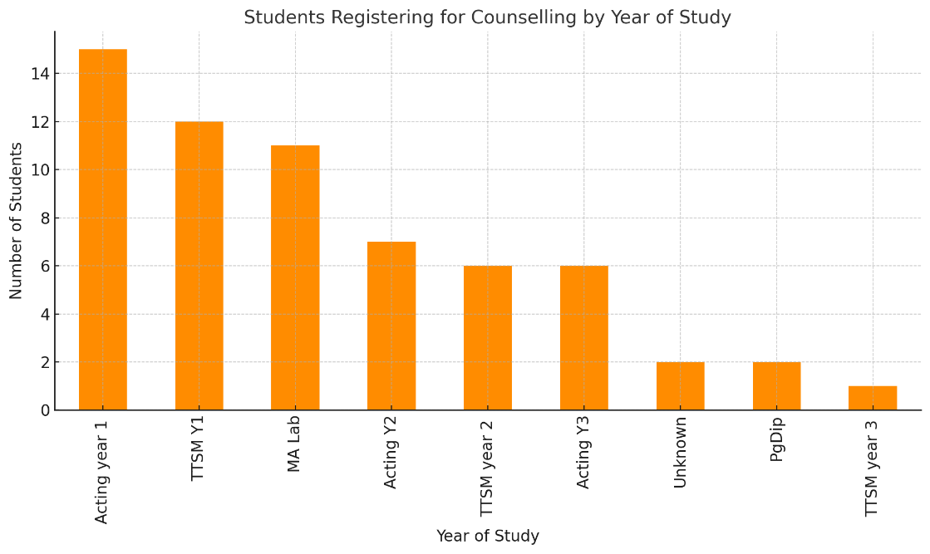

The bar chart, titled "Students Registering for Counselling by Year of Study", illustrates the distribution of students from the RADA Wellbeing Service who have sought counselling, with a total sample size of 72.
Each bar represents the number of students from various years of study accessing support.

Analysis of registrations by year of study:

1. High Demand in Early Years:
- First-year students, such as those in "TTSM year 1" and "Acting year 1," show the highest numbers seeking counselling services. This suggests that students may encounter significant personal or academic challenges when transitioning into RADA, and the RADA Wellbeing Service is playing a crucial role in supporting them during this period.
2. Decline in Later Years:
- There is a noticeable drop in the number of students seeking support in "TTSM year 2" and "TTSM year 3." This could suggest that students become more self-sufficient as they progress, or it might indicate that those in higher years are less inclined to seek help, possibly due to increased focus on their studies or a perceived stigma around counselling.

3. Postgraduate Program:
- The relatively low number of postgraduate students (e.g., "PgDip") utilizing counselling services might imply that these students either feel more self-reliant or face time constraints, limiting their engagement with the RADA Wellbeing Service.

Potential Implications for RADA Wellbeing Service:
Enhanced Support for First-Year Students:
The higher demand for counselling in the early years underscores the importance of continuing to provide robust mental health support for first-year students. This might include tailored workshops, mental health awareness programs, and peer support networks to ease the transition into RADA.
Increasing Engagement in Later Years:
The data indicating declining trend in counselling usage is among later-year students is somewhat misleading as at the time of this writing there has been increased demand from tutors for workshops for MA Lab for around interpersonal communications issues.
The RADA Wellbeing Service will maintain its current offerings, which include tailored workshops and one-on-one counselling sessions, along with Mental Health (MH) support. This approach has already been implemented this year, starting with MA Lab students, to ensure they are informed about and feel at ease using the available support resources.
This analysis provides valuable insights into how students from different academic years engage with the RADA Wellbeing Service, helping to inform strategies for enhancing mental health support throughout their educational journey.

Counselling Sessions by Ethnicity and Gender

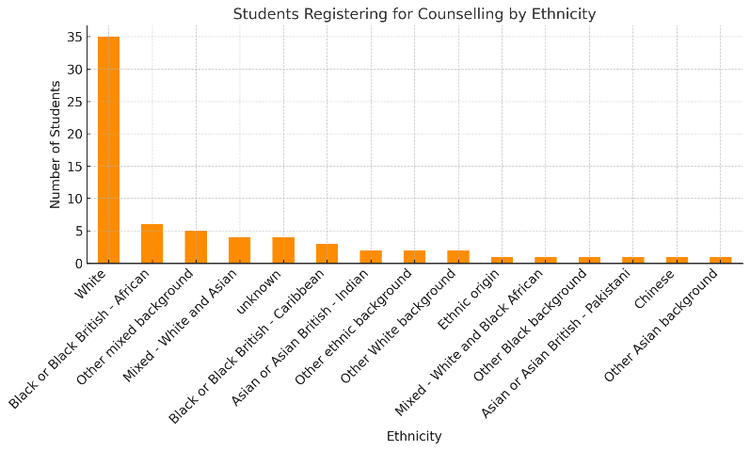 | 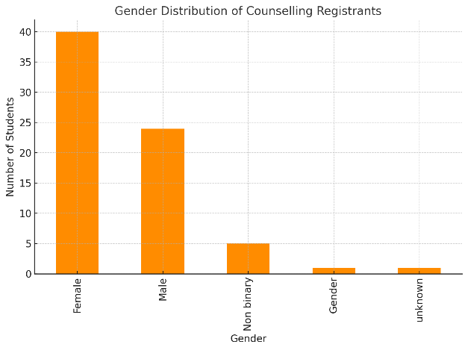

Analysis of Gender and Race
Gender Distribution
The gender distribution shows a higher number of female students, totalling 50, which is twice the number of male students, who number 25. There is a small representation of non-binary individuals and those who prefer not to disclose their gender, each group numbering 10 and 2 respectively. Additionally, there are 10 entries with unknown gender, indicating a gap in data collection or disclosure.
Ethnic Origin Distribution
The ethnic origin distribution is predominantly White. This is followed by Black or Black British - African students, with smaller representations from other mixed backgrounds, Black or Black British - Caribbean, and Mixed - White and Asian students. Other groups include Asian or Asian British - Indian, Other White background, Chinese, Other ethnic backgrounds, and Mixed - White and Black African. There are also students with unknown ethnic origin, reflecting incomplete data collection on ethnic origins.
Overall Insights
The analysis of gender and ethnic origin distribution reveals several important patterns.
There is a notable gender imbalance, with females representing most of the student population compared to males. This trend could point to underlying factors around approaching counselling and or mental health support.
In terms of ethnic diversity, the population is predominantly from white students, though there is representation from various other backgrounds as well. This highlights a degree of diversity but also suggests that some ethnic groups are more prominently represented than others.
These findings raise potential areas for further outreach both to male and ethnic minority groups. Additionally, continuing to improve the data collection process which is already underway for the next academic year.

Presenting issues

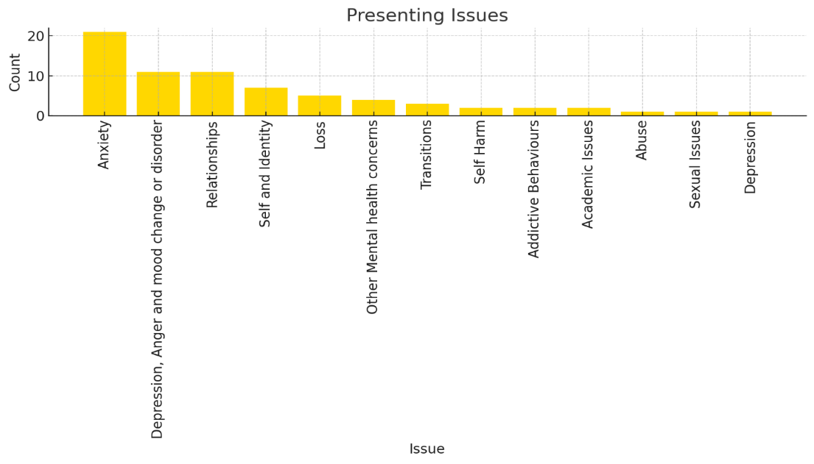

Breakdown of Presenting Issues:
- Anxiety – 29.6%
- Depression, Anger, and Mood Change or Disorder – 15.5%
- Relationships – 15.5%
- Self and Identity – 9.9%
- Loss – 7.0%
- Other Mental Health Concerns – 5.6%
- Transitions – 4.2%
- Self-Harm – 2.8%
- Addictive Behaviours – 2.8%
- Academic Issues – 2.8%
- Abuse – 1.4%
- Sexual Issues – 1.4%
- Depression – 1.4%

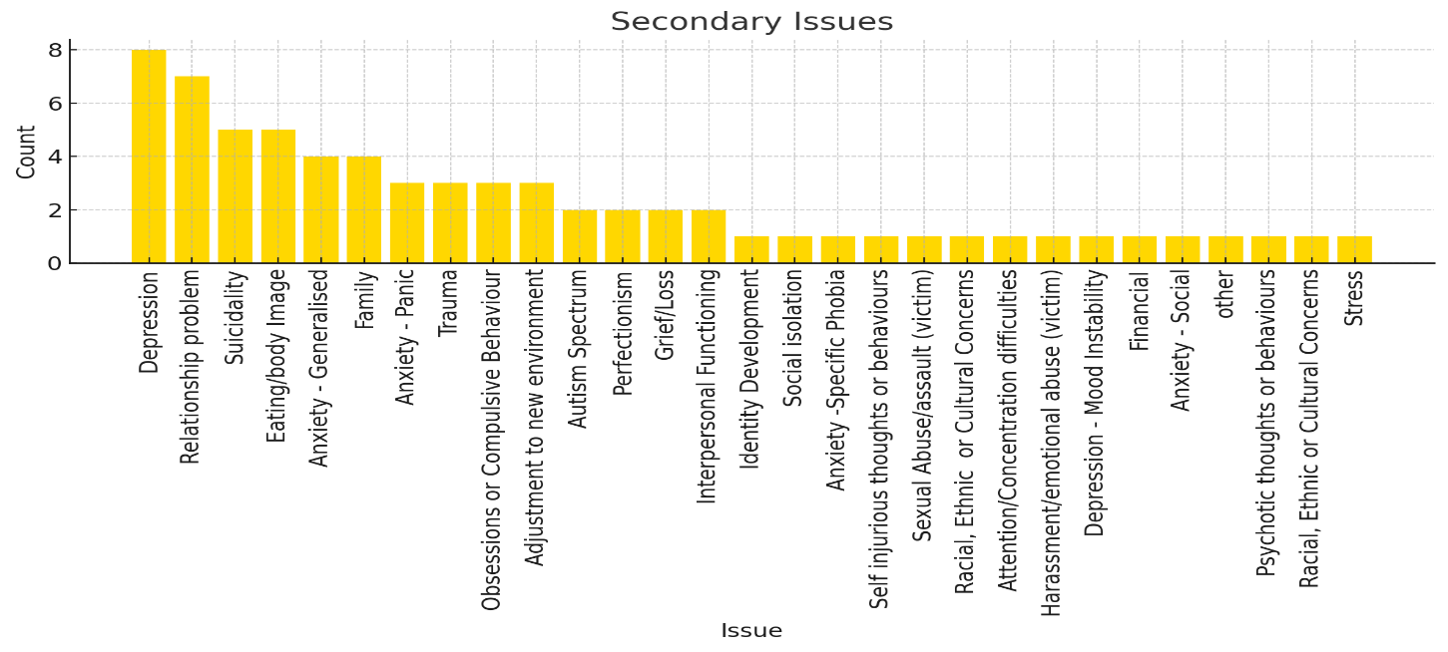

Analysis of Presenting Issues

The analysis of the data on presenting and secondary issues reveals distinct patterns in the types of concerns students bring to counselling services.
In the Presenting Issues category, the most frequently reported concerns include:
Anxiety is a standout issue, with 21 mentions, suggesting it is a pervasive concern among the population.
Depression, anger and mood disorders, relationship difficulties , and issues related to identity also appear frequently, reflecting emotional, interpersonal, and self-related struggles.
A wide range of other issues, such as self-harm , transitions , and addictive behaviours , are present but less common, showing the variety of challenges people face when seeking support.

Counselling Drop-in Sessions
The RADA counselling service provides drop-in appointments for students to receive immediate support and guidance on various personal and academic issues.
The RADA Counselling Service recorded a total of 77 drop-in sessions between September 2023 and September 2024, averaging around 6 sessions per month.
The busiest periods were March and June 2024, with 12 drop-ins each, while the lowest was in August 2024, with just 1 session.
The fluctuations in usage may correspond to the intensity of student projects and performances, with higher demand during periods of increased pressure and lower engagement during breaks or less busy times in the academic calendar.
The drop-in appointments data spans from September 2023 to September 2024, covering the full academic year including both the Autumn term of 2023 and the Spring/Summer terms of 2024.

Bar Graph of Drop-in Attendance (Month-by-Month)

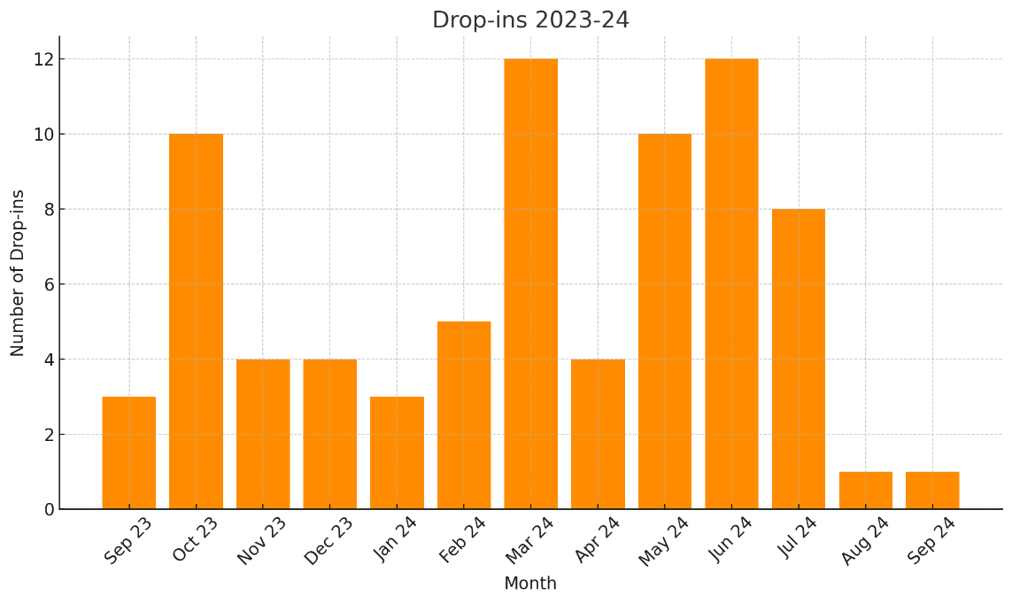

Analysis of Drop-in Sessions

The RADA counselling service provides drop-in appointments for students to receive immediate support and guidance on various personal and academic issues.
The drop-in appointments data spans from 9 September 2023 to 23 September 2024, covering the full academic year including both the Autumn term of 2023 and the Spring/Summer terms of 2024.
For the academic year 2023-24 there were a total of 77 drop-ins recorded.
The drop-in activity fluctuated, with some months showing higher engagement and others reflecting more stable or reduced attendance. Overall, the data points to two distinct periods of activity: a higher engagement in the autumn months, followed by a steadier, lower level of activity through the spring and summer.
Autumn (Sept - Dec 23)
In the autumn months, drop-ins started at 3 in September 2023 , but quickly rose to 10 in October 2023 , which was the peak for the academic year. This increase could be attributed to the new academic year kicking off, as students settle into their routines and seek support early on. However, as the term progressed, drop-ins dropped to 4 in November and continued at 4 in December 2023 , reflecting a levelling off in engagement as students became more involved in their academic work and other activities. This pattern is typical for many academic environments, with high engagement at the start and a steady decrease as the year goes on.
Spring / Summer (January 24 - September 24)
The spring and summer months (January to September 2024) exhibited more consistent, though generally lower, drop-in activity compared to autumn. January 2024 started with 3 drop-ins , similar to September. The number of drop-ins remained steady through the early months of the year, with slight fluctuations in subsequent months, reflecting the influence of projects, academic pressure, and holiday periods, which often limit the ability or need for students to attend drop-in sessions.
As the summer period progresses, drop-ins typically decline, as most students will be on summer break. This steady trend suggests that the spring and summer months are influenced heavily by the academic calendar, with fewer students actively engaging in support services compared to the start of the year.
Throughout the spring and summer period, while the overall drop-in numbers remained lower than in the autumn, the consistency suggests that a core group of students continues to seek support even during quieter academic periods.

Total Counselling and Drop-in Sessions

The Counselling Service statistical summary of the total counselling sessions, total drop-in sessions, and the combined number of both for the 2023-2024 academic year:

Total Counselling Sessions: 196
Total Drop-in Sessions: 77
Combined Total Sessions: 273
Average counselling sessions per client seen 4.6

Disabilities Reported by RADA Students Receiving Counselling

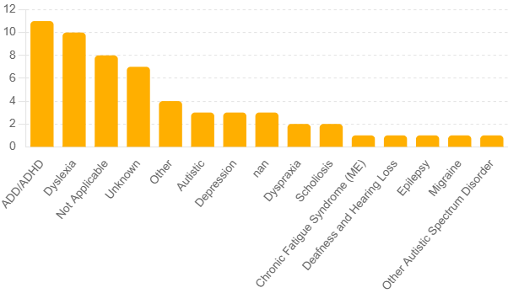

Analysis of Disabilities Reported in Counselling
The above bar chart illustrates the distribution of various disabilities reported by RADA students receiving counselling during the 2023-24 academic year.
Attention Deficit Disorder (ADD/ADHD) is the most reported disability, indicating a significant prevalence among the student population. This highlights a need for specialized support and resources to cater to students dealing with ADD/ADHD.
Following closely are Dyslexia and students with no reported disabilities, both showing substantial numbers. Dyslexia, being a common learning difficulty, underscores the importance of tailored educational strategies and counselling services. The significant number of students with no reported disabilities could suggest either a lack of identification or a lower prevalence of other specific conditions.

Other disabilities such as Autism Spectrum Disorder, Anxiety, and Depression are also reported, albeit in smaller numbers. These figures emphasize the diverse needs of the student body and the necessity for a broad range of mental health and educational support services to ensure all students receive appropriate assistance and accommodations.

SUMMARY

Statistics in Comparison to Past Two Previous Academic Years
In the 2021-2022 academic year, there were 154 total counselling sessions. The most common presenting issues were mental health (44%), adverse life experiences (42%), learning/academic issues (12%), physical health (8%), and addiction (8%).
In the 2022-2023 academic year, the number of total counselling sessions decreased by 19% to 124. The key presenting issues were mental health (42%), adverse life experiences (30%), learning/academic issues (12%), physical health (12%), and addiction (4%).
In the 2023-2024 academic year, there was a significant uptake in counselling, with a 58% increase in total counselling sessions, reaching 196 counselling sessions.
This significant rise can be attributed to the increased cross-RADA activities in the previous year, which successfully raised awareness among staff and students about the Wellbeing Service.
The most common presenting issues were anxiety, relationships, and depression/anger/mood changes. Additionally, secondary issues such as eating/body image concerns and suicidality were prevalent, indicating complex underlying struggles that students face.

Key Counselling Statistics and Presenting Issues

The substantial engagement in counselling included a combination of ongoing and brief sessions, as well as drop-in appointments aimed at addressing urgent needs.
The counselling service was crucial in supporting students through a variety of mental health challenges, including stress, anxiety, depression, and personal difficulties. Feedback from students indicated a significant positive impact on their resilience and academic performance.
Overall, the consistent utilisation of counselling services throughout the year underscores the critical need for robust mental health support at RADA. The prominence of issues like anxiety, relationship difficulties, and suicidality suggests a multifaceted approach is necessary, involving preventative measures, crisis intervention, and ongoing support. This comprehensive strategy is essential to fostering a healthy and supportive environment for students as they navigate their academic and personal lives.

Conclusion and Recommendations

The RADA Student Wellbeing Service has grown and significantly changed this academic year, with the development of one year old Disability Service providing a package of support to students who are registered disabled under the Equality Act.
There was significant uptake in counselling, with a 58% increase in total counselling sessions, combined with reaching 196 sessions.
These changes are part of the service's commitment to providing students with the support they need to thrive.
Recommendations
- The Wellbeing Service will explore partnerships with external mental health organizations to provide supplementary support and resources to students.

- Introduce regular mental health check-in surveys to monitor the well-being of students and identify those who may need additional support early on.
- The service should continue to promote a ‘whole universities; approach to mental health safeguarding awareness, as recommended by Universities UK and the Office for Students.
- The Disability service will continue to support students with registered disability as well as advise on Learning Agreements.
- The Counselling Service will continue to diversify counselling support, both 1:1, support groups and the provision of training materials.
- The Wellbeing Service will provide input for the Fitness to Train process, to provide earlier interventions for students who need support.
- Integrate Wellbeing into Curriculum. Collaborate with academic staff to embed wellbeing and mental health education through workshops, seminars, and modules on stress management, resilience, and mental health awareness.

Disability Services Section

Summary of Disability Service Provision

Analysis of Disability Data
The summary of students having had any form of contact (in person, remote or via email) with the Disability Coordinator by course at RADA for the academic year from September 2023 to September 2024 is as follows:
- Total: 78 students, made up of:
- BA Acting: 37 students (47.4%)
- TTSM (Technical Theatre & Stage Management): 35 students (44.9%)
- PgDip Theatre Costume: 2 students (2.6%)
- MA Theatre Lab: 4 students (5.1%)
Percentage of whole student body having had contact with the Disability Coordinator : 42%
- Percentage ofBA Acting course having had contact with the Disability Coordinator: 44%
- Percentage of TTSM course having had contact with the Disability Coordinator: 47%
- Percentage of PgDip Theatre Costume course having had contact with the Disability Coordinator: 33%
- Percentage of MA Theatre Lab course having had contact with the Disability Coordinator: 21%
Analysis:
TTSM has the highest proportion of students within the course who have had contact with the Disability Coordinator (47%). This may be the result of the technical and practical challenges of the course requiring a high number of adjustments to be made.
BA Acting has the second highest proportion of students within the course who have had contact with the Disability Coordinator (44%). This could indicate a high demand for disability support due to the intense nature of the program.
The MA course may have the lowest proportion of students who have had contact with the Disability Coordinator (21%) due to the high number of international students who may be less likely to be aware of disability support. We aim to collect more accurate data on student needs within the MA course in 2024-25 to better understand why this group has the lowest proportion of students having contact with the Disability Coordinator.
-

Disability Services Report Data
This information is based on data collected between September 2023 – August 2024.
Disability team data
In-house team:
Disability Coordinator - 0.8FTE
5 x Non-Medical Helpers:
- 2 x Specialist Mentors (Mental Health) – Sessional work;
- 2 x Study Skills Tutor (SpLD) - Sessional work;
- 1 x Specialist Mentors (ASC) - Sessional work.
External communication:
Goldsmiths, University of London - Student Support Services: Provision of supervision and mentoring for Disability Coordinator.
CF Psychology – educational psychology practice: learning difficulties (SpLD) diagnosis assessment service.
Membership:
National Association of Disability Practitioners (Disability Coordinator attended NADP Annual Conference 2024).

Overall student support 2023-24
Total number of students in the disability service system (those having declared a disability and/or having sought disability support): 82
BA Acting: 40
Y1: 12
Y2: 13
Y3: 15
TTSM: 36
FdA Y1: 17
FdA Y2: 7
BA Y1: 12
MA Theatre Lab: 4
PgDip Theatre Costume: 2
Y2: 2
Total number of students in receipt of DSA: 18
BA Acting: 9
Y1: 1
Y2: 4
Y3: 4
TTSM: 9
FdA Y1: 3
FdA Y2: 3
BA Y1: 3
Number of students who received an SpLD diagnostic assessment through RADA: 9
BA Acting: 7
Y1: 3
Y2: 2
Y3: 2
TTSM: 2
FdA Y1: 1
BA Y1: 1
Number students accessing NMH sessions: 13
BA Acting: 8
Y1: 1
Y2: 4
Y3: 3
TTSM: 4
FdA Y1: 1
BA Y1: 3
PgDip Theatre Costume: 1
Y2: 1
Number of students accessing NMH study skills sessions: 9
BA Acting: 6
Y1: 1
Y2: 3
Y3: 2
TTSM: 3
FdA Y1: 1
BA Y1: 2
Number of students accessing NMH specialist mentor sessions: 8
BA Acting: 5
Y1: 1
Y2: 2
Y3: 2
TTSM: 1
Y3: 1
MA Theatre Lab: 1
PgDip Theatre Costume: 1
Y2: 1
Number of 1:1 NMH in-house support sessions: 188
Number of students who have had meetings with the Disability Coordinator: 37
BA Acting: 21
Y1: 8
Y2: 7
Y3: 6
TTSM: 12
FdA Y1: 4
FdA Y2: 3
BA Y1: 5
MA Theatre Lab: 3
PgDip Theatre Costume: 1
Y2: 1
Number of students who have had any form of contact (in person, remote or via email) with the Disability Coordinator: 78
BA Acting: 37
Y1: 12
Y2: 11
Y3: 14
TTSM: 35
FdA Y1: 16
FdA Y2: 7
BA Y1: 12
MA Theatre Lab: 4
PgDip Theatre Costume: 2
Y2: 2

(This does not include drop-in sessions, which are discussed following this section.)
(We exclude Sept 24 as this period ended on 8 September.)

